|  |  |
| --- | --- |
| Course Name | ITD 2313 – Script Programming |
| Instructor | Prof M |
| Student Name | Pierre Tadong |
| Due date | 6/26/2022 |
| Grade |  |
| Grading Comments |  |

# Page 203

## Project # 1

### Special Instructions:

1. This project is to be done in a python program file. The file needs to be submitted as part of the submission for this assignment. Place the program file into the zip file that is submitted for this assignment.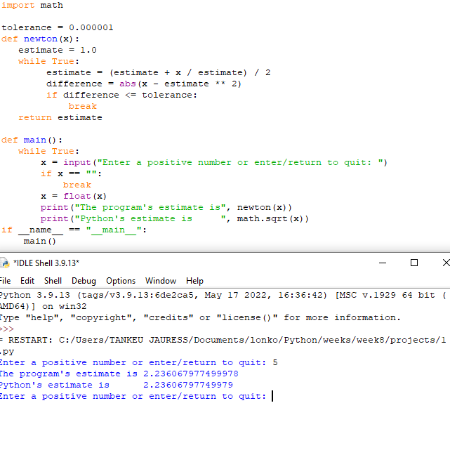

## Project # 2

### Special Instructions:

1. This project is to be done in a python program file. The file needs to be submitted as part of the submission for this assignment. Place the program file into the zip file that is submitted for this assignment.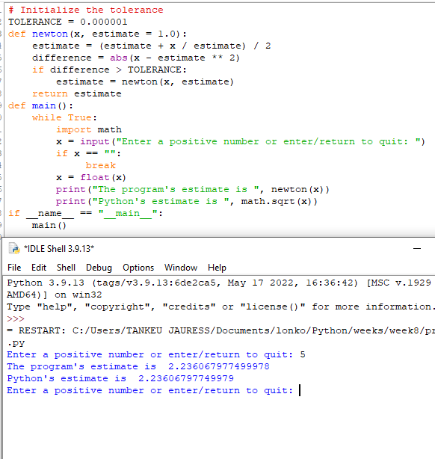

## Project # 3

### Special Instructions:

1. This project is to be done in a python program file. The file needs to be submitted as part of the submission for this assignment. Place the program file into the zip file that is submitted for this assignment.